TOP 50 EXCEL FORMULAE FOR DATA Enthusiasts BY ANKIT KUMAR

1. SUM

Adds up all the numbers in a specified range.

2. AVERAGE

Description: Calculates the average of numbers in a range.

3. IF

* Formula: =IF(A1>10, "Yes", "No")
* Description: Returns one value if a condition is true, and another value if it’s false.

4. VLOOKUP

* Formula: =VLOOKUP(A1, B1:C10, 2, FALSE)

VLOOKUP Excel ka ek function hai jo ek column mein di gayi value ko doosre column ki corresponding value ke saath match karta hai.

Vlookup me 4 argument hote h

vlookup(lookup_value, table_array, col_index_num, [range_lookup])

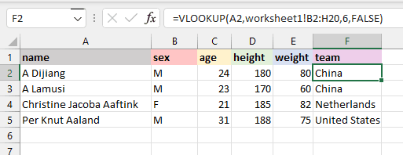

5. HLOOKUP

* Formula: =HLOOKUP(A1, A1:D4, 2, FALSE)
* Description: Similar to VLOOKUP but searches horizontally

7. MATCH

* Formula: =MATCH(A1, B1:B10, 0)
* Description: Returns the relative position of an item in a range.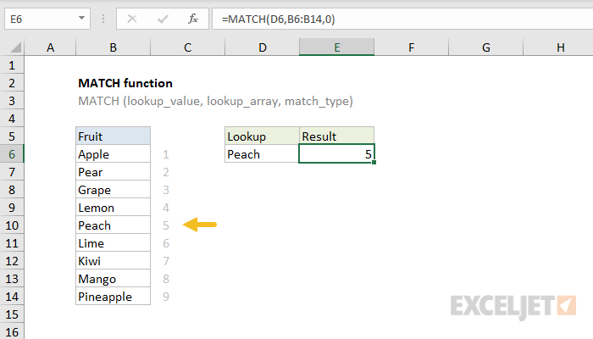

8. CONCATENATE (or CONCAT)

* Formula: =CONCATENATE(A1, " ", B1)
* Description: Combines multiple values into one string.

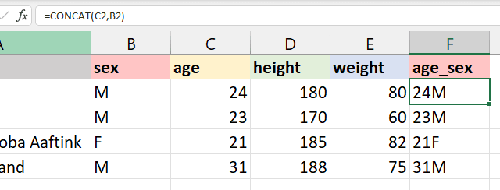

9. COUNTIF

* Formula: =COUNTIF(A1:A10, ">5")
* Description: Counts the number of cells in a range that meet a single criterion.

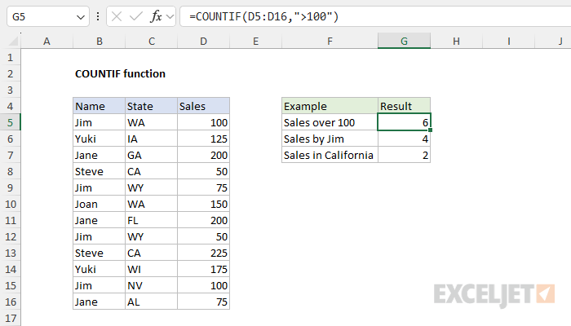

10. SUMIF

* Formula: =SUMIF(A1:A10, ">5")
* Description: Adds the cells in a range that meet a specified condition.

11. COUNTIFS

* Formula: =COUNTIFS(A1:A10, ">5", B1:B10, "<10")
* Description: Counts the number of cells that meet multiple criteria.

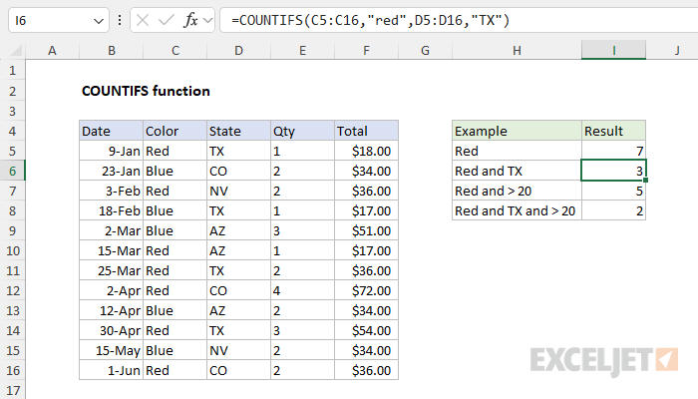

12. SUMIFS

* Formula: =SUMIFS(A1:A10, B1:B10, ">5")
* Description: Adds the cells that meet multiple conditions.

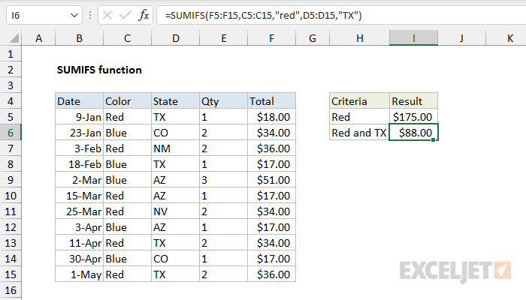

13. LEFT

* Formula: =LEFT(A1, 3)
* Description: Returns a specified number of characters from the start of a text string.

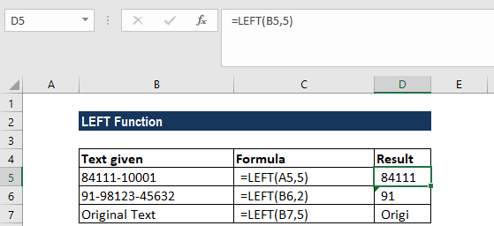

14. RIGHT

* Formula: =RIGHT(A1, 3)
* Description: Returns a specified number of characters from the end of a text string.

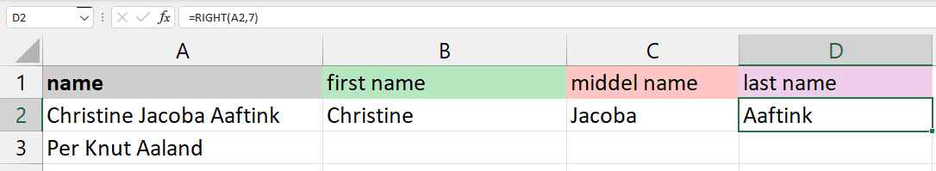

15. LEN

* Formula: =LEN(A1)
* Description: Returns the number of characters in a text string.

16. TRIM

* Formula: =TRIM(A1)
* Description: Removes all extra spaces from text except for single spaces between words.

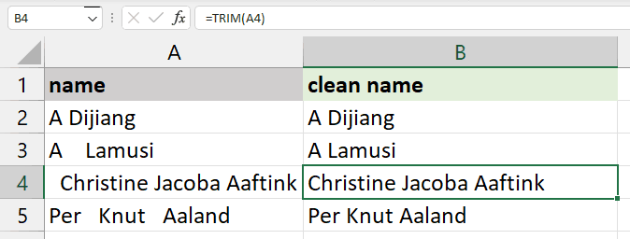

17. TEXT

* Formula: =TEXT(A1, "dd/mm/yyyy")
* Description: Formats a number or date into a text string with a specified format.

*18. PROPER

* Formula: =PROPER(A1)
* Description: Capitalizes the first letter of each word in a text string.

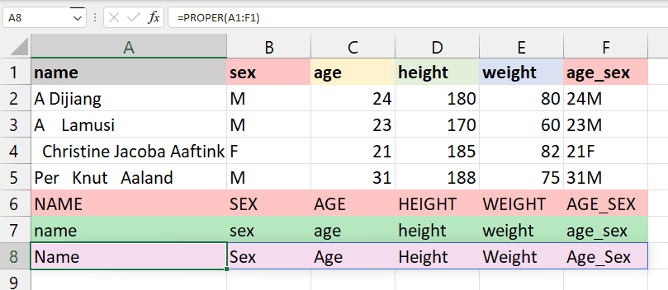

19. NOW

* Formula: =NOW()
* Description: Returns the current date and time.

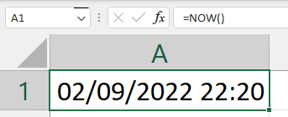

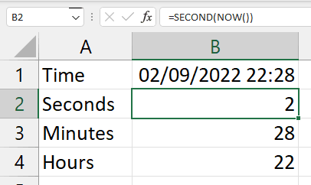

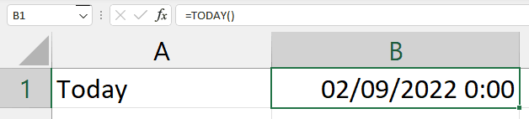

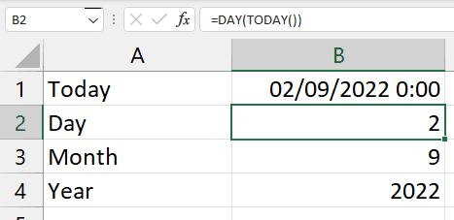

20. RANK

* Formula: =RANK(A1, A1:A10)
* Description: Returns the rank of a number in a list of numbers.

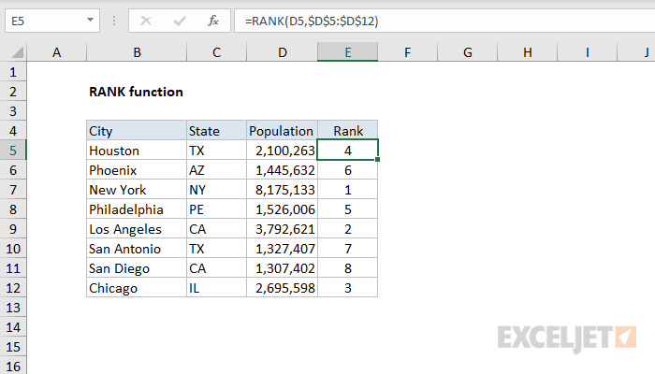

21 textsplit

Excel mein, `TEXTSPLIT` function kisi text ko alag-alag parts mein tod ke alag cells mein daalne ke kaam aata hai, jaise agar words ko comma ya space se alag karna ho.

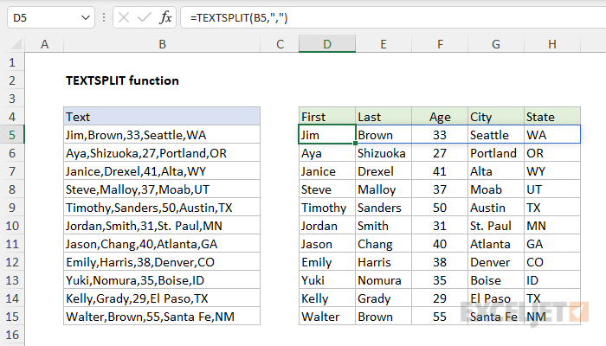

22. EXACT

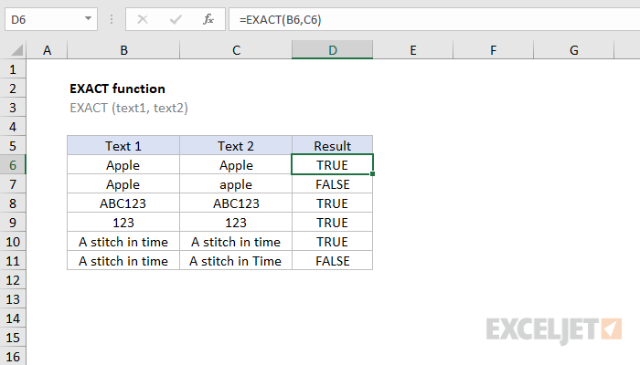

23. SUM PRODUCT

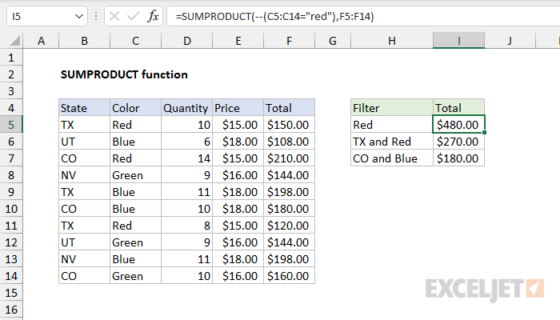

24. SUBSTITUDE

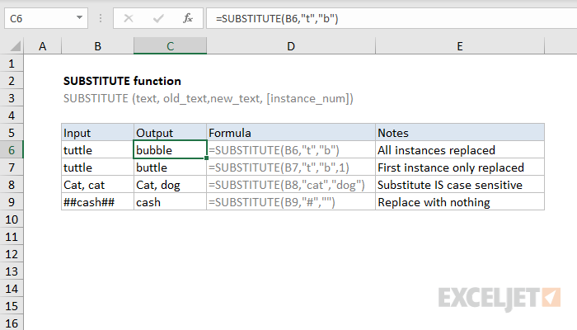

25. IF ERROR

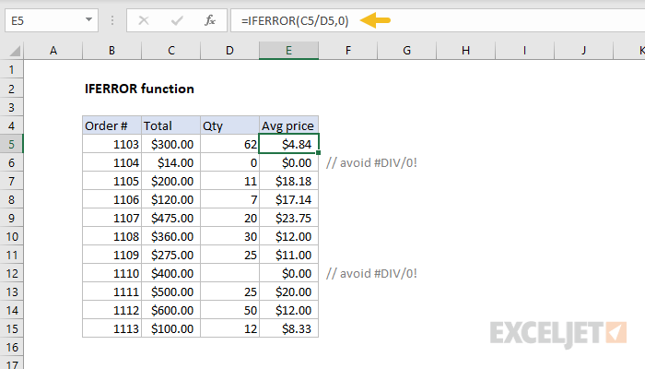

26. XLOOKUP

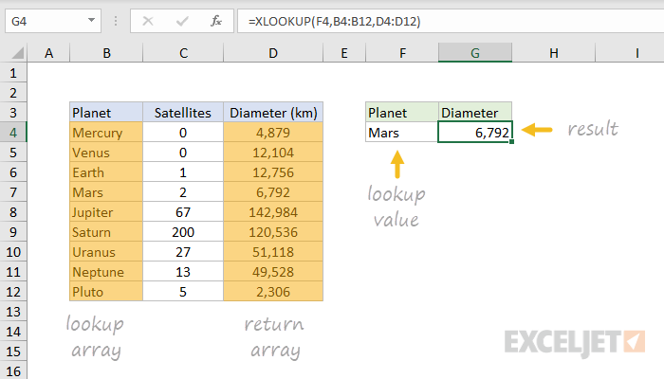

27. COUNTA()

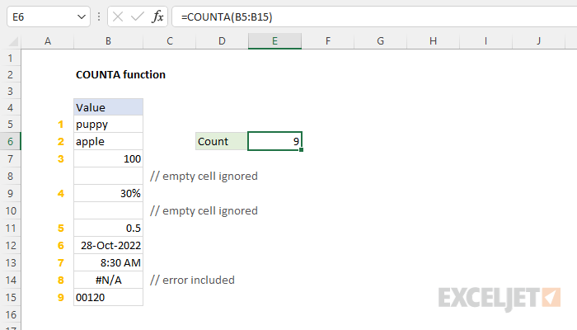

28. INDEX()

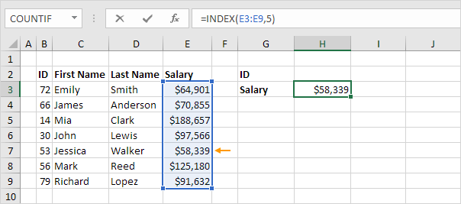

=INDEX(A1:J9,5,7)

5 for row

7 for column

29. MID()

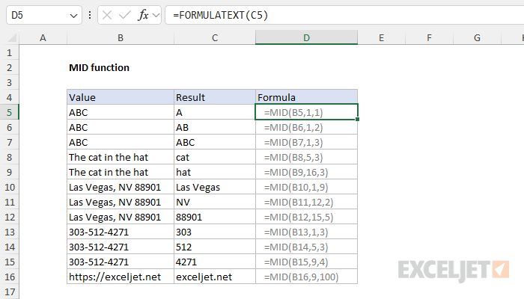

30. PMT(B4/12, B3,-B2)

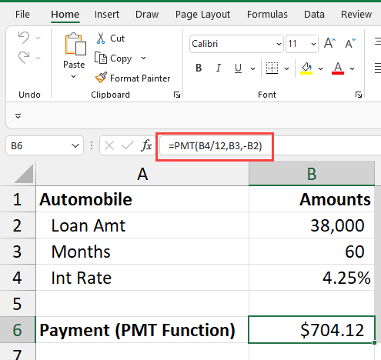

31. Textjoin

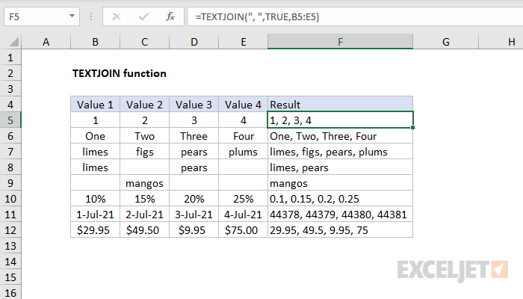

32. Upper

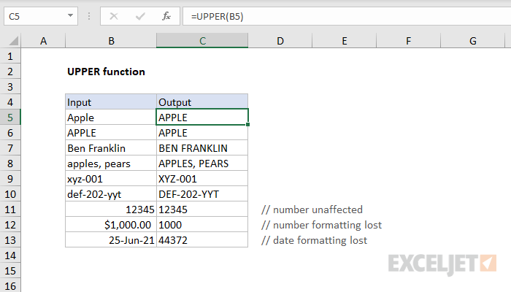

33. Lower

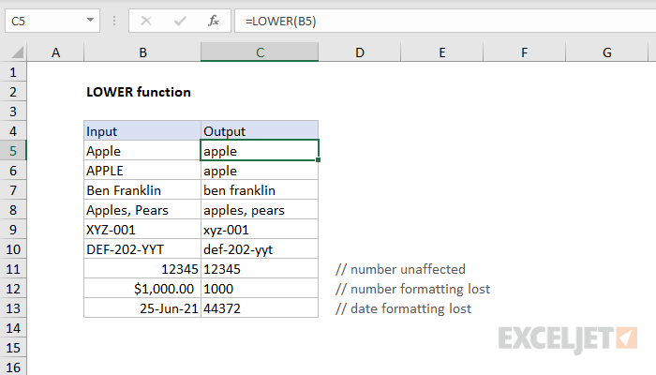

34. Proper

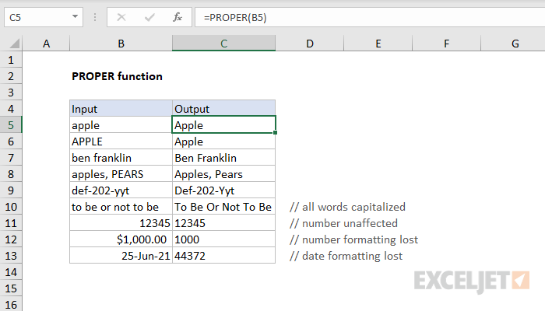

35. Round/

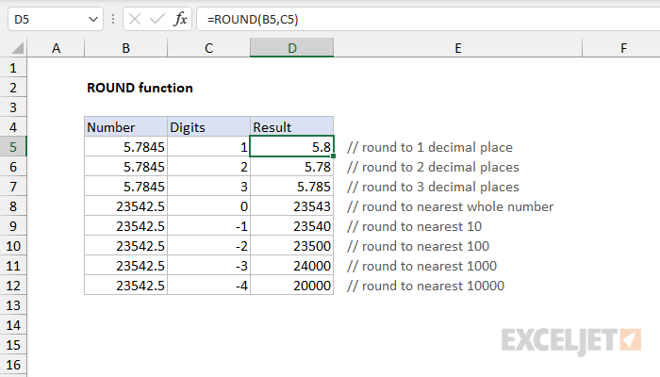

36. Roundup

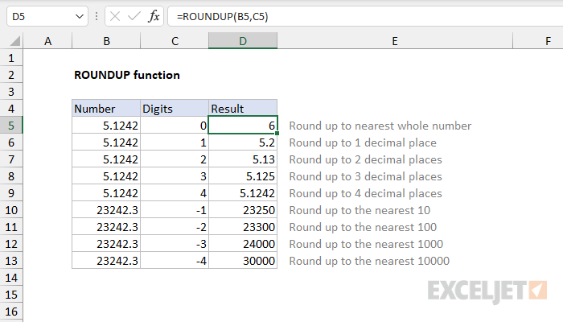

37. Roundown

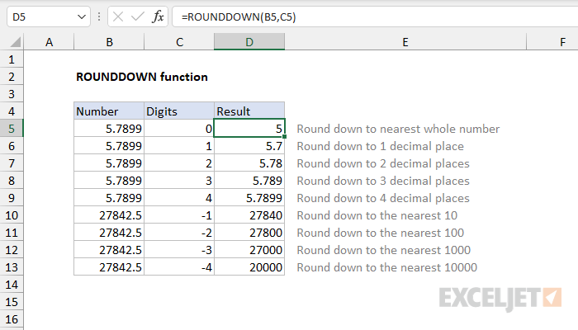

**38. dateif**

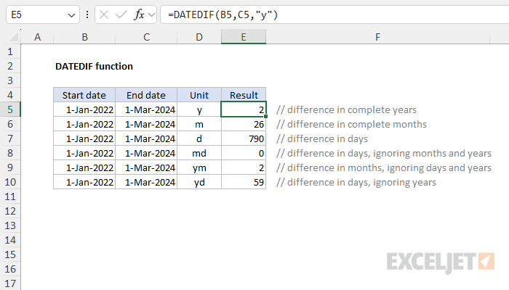

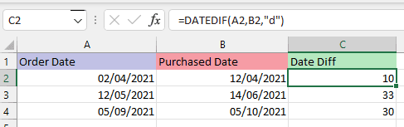

39. Now

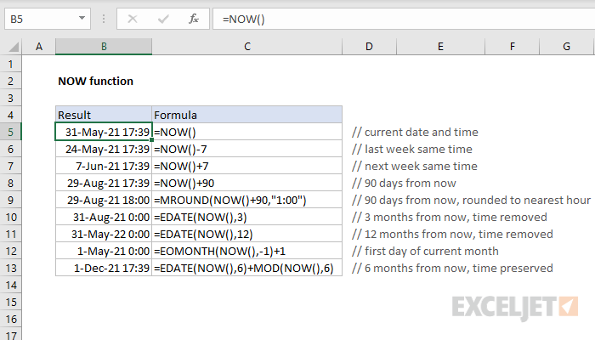

40. Today

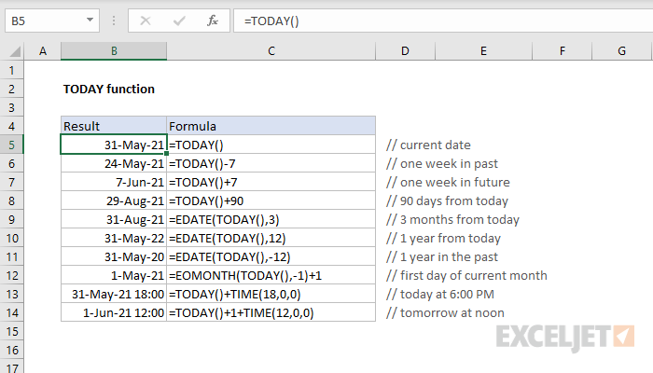

41. Ifs

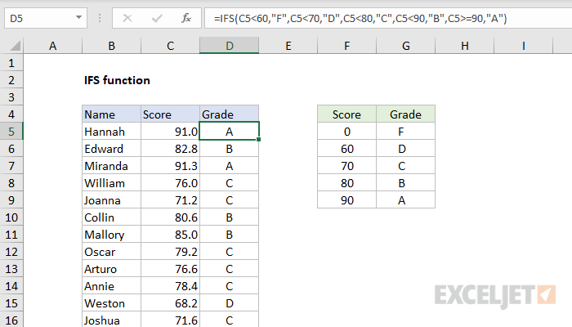

42. Power

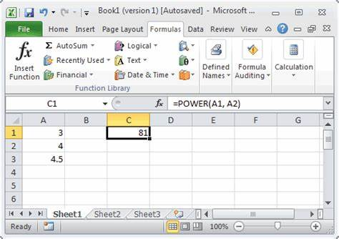

43. CEILING

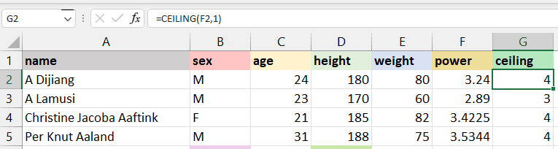

44. Floor

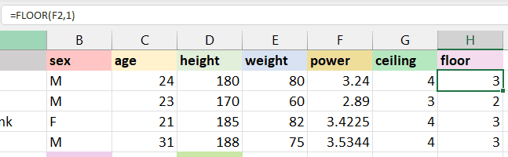

45. Replace

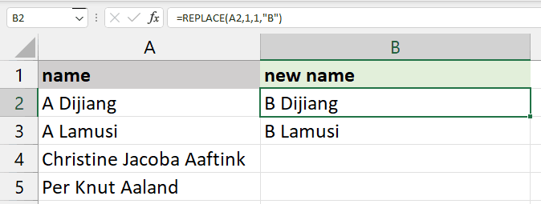

46. Substitute

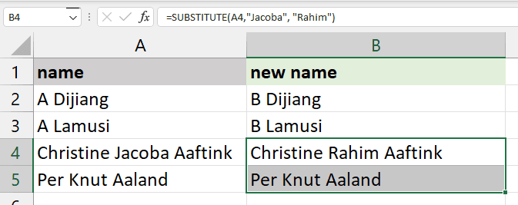

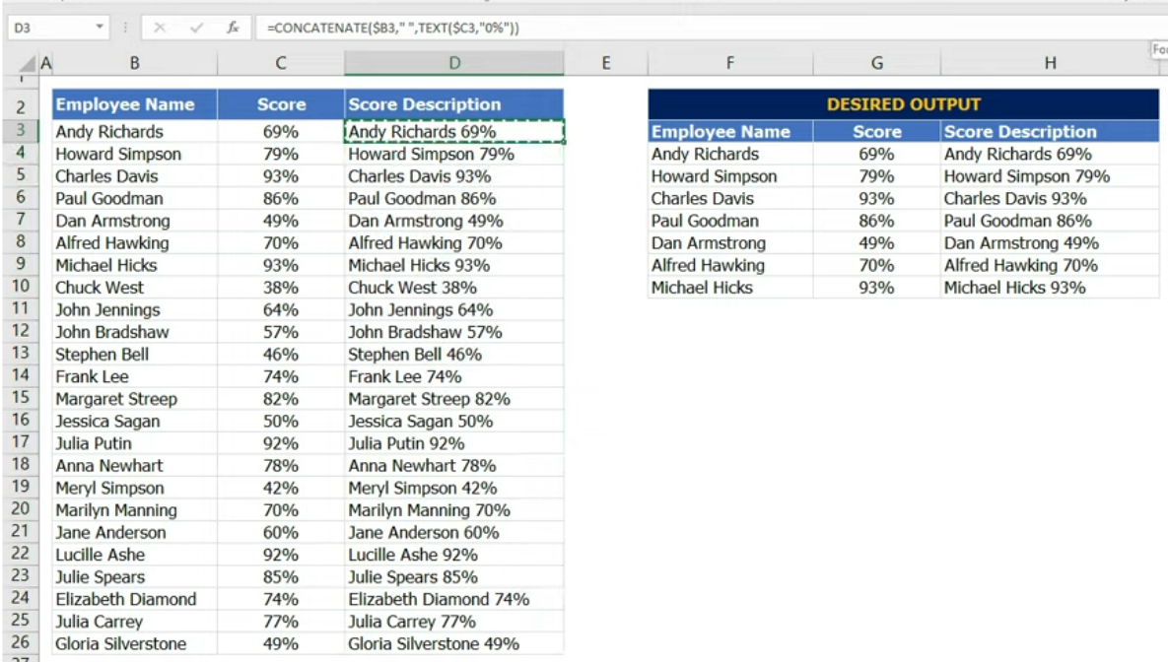

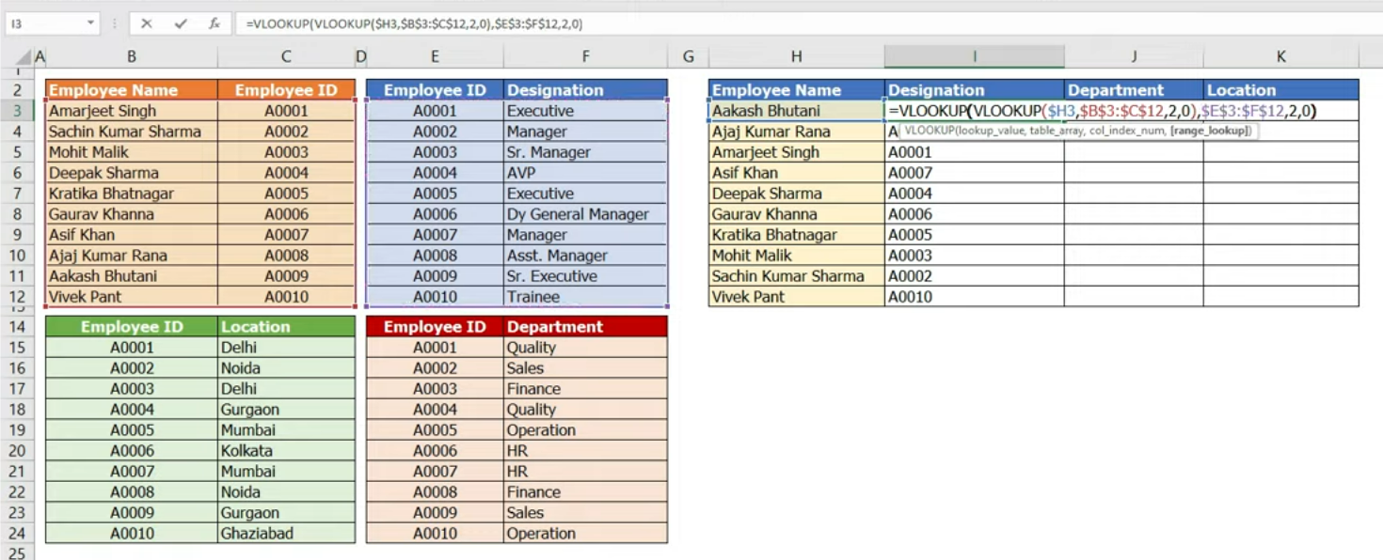

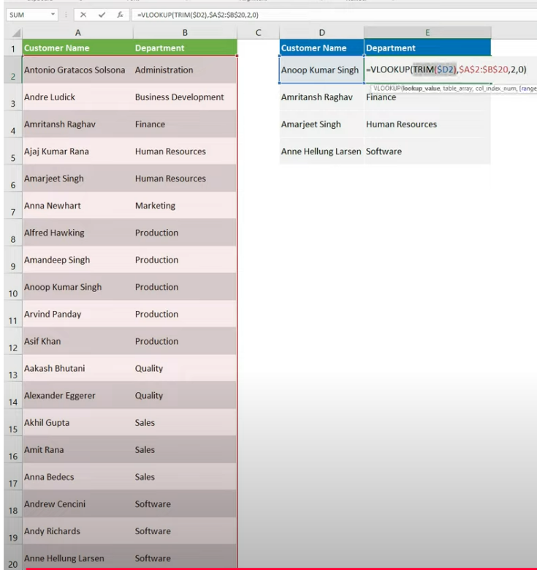

Conditional formatting mein new rules mein Jha par a hai wo wale row dikhata h

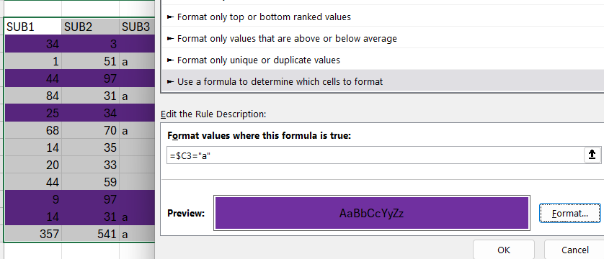

Input se data k row/s find with highlight karta h

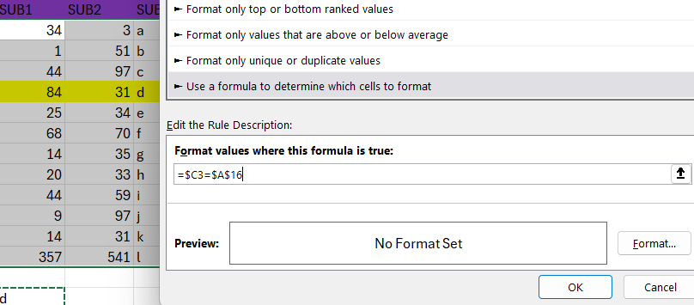

Jis text me se extra spaces nhi hat te to =subsitute(cell,char(160),””) se forcefully spaces hat jate h

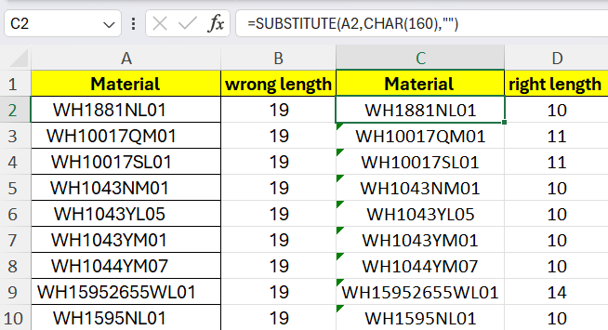

Q

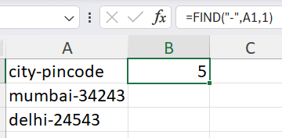

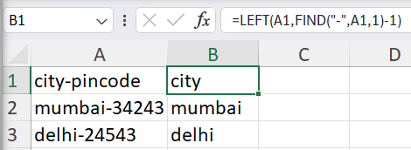

Data validation

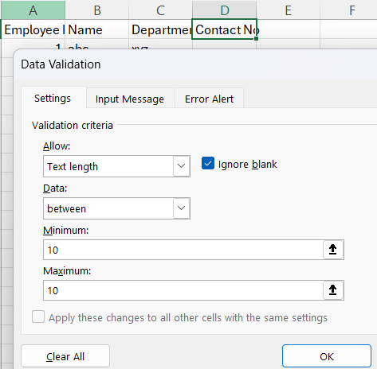

New cell par sort karta h

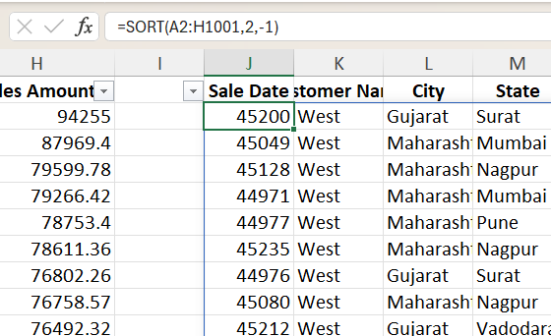

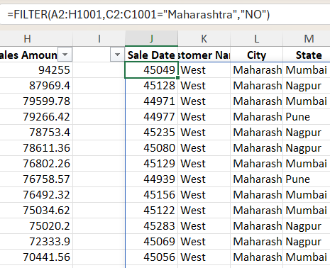

Selected data ko naame deta h aur change karta h

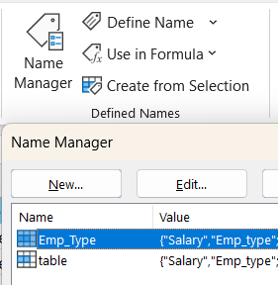

Dropdown list banane k liye

Data validation -> list -> select rows or columns

Date format

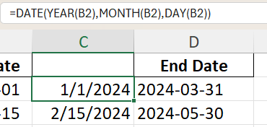

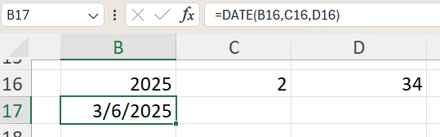

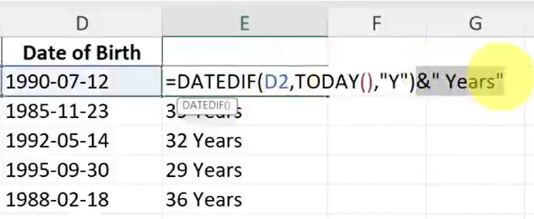

1years 1months 1 days format

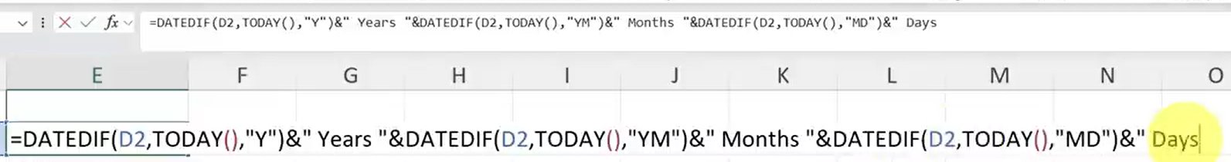

30 dec 2024 format k liye

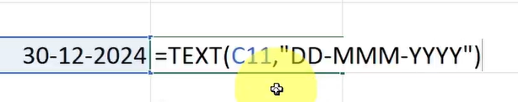

Alt + n + v + t

Insert pivot table